**IoT Platform for Condition Monitoring of Industrial Motors with Custom Notifications**

Project Mentor: Group Members:

Dr. Rajat Kumar Singh 1) Aditya Anand (IEC2016057)

(Associate Professor, Department of ECE, IIIT-A) 2) Apoorv Mahajan (IEC2016013)

3) Prachi Shankar (IEC2016010)

**Abstract :- An era of smart things have already arrived that is based on IoT(Internet of Things). With IoT we can get more out of our commonly used devices by connecting them to the cloud in order to either publish data of the device on the cloud or triggering an action. This IoT platform can be equivalently used for the condition monitoring of industrial motors. The aim of this project is to design a pathway that can unveil this IoT technology to monitor and diagnose the most concerned parameters of the industrial motors and issue notifications about the same. The proposed method will enable real time condition monitoring, and issue notifications if any of the parameters exceed their permissible limits so that necessary action can be taken right away.**

**INTRODUCTION**

The fault diagnosis and protection of electrical machinery is a quintessential aspect pertaining to every industry. Induction motor is one of the most widely used machine in an industry.It’s continuous condition monitoring reduces the maintenance cost as well as helps to cope up with the risk of unexpected failures by allowing the early detection of potentially catastrophic faults that might cause unpredictable delay. Apart from the robustness, high starting torque, efficiency and reliability of the induction motor which forms the backbone of the several industries, they are also subjected to many faults.

Most common failure mechanism in induction motor includes stator faults, Rotor faults, bearing faults and winding faults.Other external factors such as lubrication, motor ventilation, electrical factors such as over voltage ,alignments and motor load results in motor vibrations or motor temperature rising to critical levels which might not be considered as a healthy situation of operation.

Here condition monitoring comes into picture to avoid downtime of any industry and assist maintenance before any failure occurs.Thus we can have an accurate means of condition assessment and fault diagnosis.

**MOTIVATION**

Even Indian Railways will be soon inducting this special technology in form of smart coaches. Smart coach is an inexpensive use of IOT platform.These smart coaches uses several sensors which are based on real time monitoring.Real time fault detection is one of the mainstays of this project.

Detection of bearing fault at this early stage will help prevent incidents and maintenance schedules can be planned accordingly. To this end, the mainstay of the smart coach would be the wireless sensor

modes that, once fitted on every wheel, help monitor the health of the wheel and its bearings.Once deployed in volume, these sensors would also be able to monitor track health on a real-time basis, resulting in improved safety, higher utilisation and reduced operation costs by enabling predictive maintenance and reduction in sudden catastrophic failures of the railway assets.

This model has found great acceptance in other parts of the world - hence it would be beneficial to expand it and use in real time monitoring of industrial equipments.

Even in case of failures, we can do a case study by looking at the log data to get deeper insights of the failure and take corrective measures in the future based on the current statistics to prevent further failures, for example, by decreasing the maximum permissible parameter value.

**BLOCK DIAGRAM**

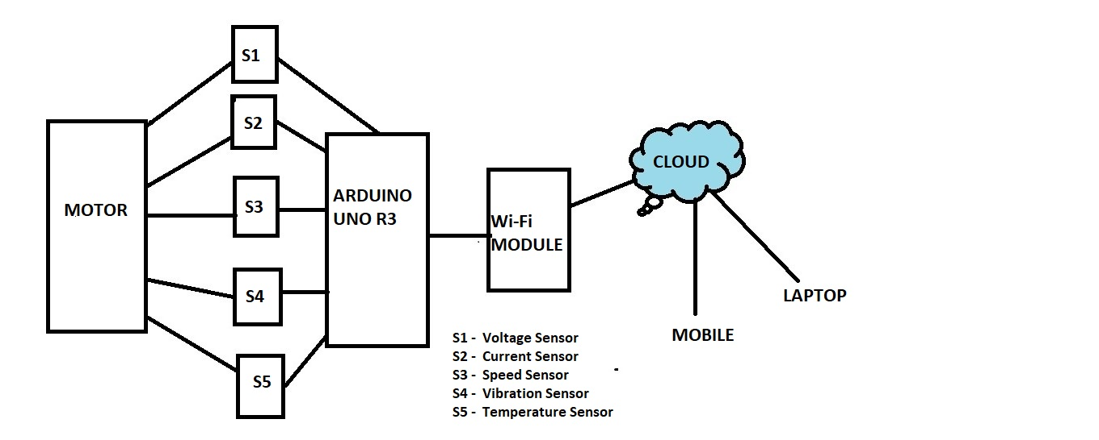

**Resources Required**

**ARDUINO UNO R3**

●Microcontroller: ATmega328

●Operating Voltage: 5V

●Input Voltage (recommended): 7-12 V

●Digital I/O Pins: 14 (of which 6 provide PWM output)

●Analog Input Pins: 6

●Flash Memory: 32 KB of which 0.5 KB used by bootloader

●SRAM: 2 KB (ATmega328)

●Clock Speed: 16 MHz

**ESP8266 WiFi Module**

●Processor: 32-bit microprocessor 80 MHz crystal oscillator

● 32 kB RAM

●External QSPI flash: up to 16 MB is supported (512 KB to 4 MB)

●4 GPIO pins.

●1MB flash memory

**CURRENT SENSOR (ACS712)**

●Supply Voltage: 4.5V ~ 5.5V DC

●Measure Current Range: -20A ~ 20A

●Sensitivity: 100mV/A

●Voltage at 0A: VCC/2

●Scale Factor: 185 mV per Amp

**SW-420 VIBRATION SENSOR**

●Digital output Supply voltage:3.3V-5V

●On-board LM393 comparator chip by Texas Instruments

**SPEED SENSOR**

●groove optical coupling sensor, width 5mm.

●If it covered, it will output high level; otherwise, its output low level.

●The working voltage of 3.3V to 5V.

●Output: digital switch output (0 and 1).

●Uses the LM393 wide voltage comparator.

**TEMPERATURE SENSOR (LM-35)**

●Calibrated directly in ° Celsius (Centigrade)

●Linear a 10.0 mV/°C scale factor

●0.5°C accuracy guaranteeable (at a25°C)

●Rated for 150°C range

●Suitable for remote applications

●Operates from 4 to 30 volts

**CURRENT PROGRESS**

1. All the relevant information about the project has been gathered.
2. All components including sensors have been bought.
3. ESP8266 libraries were installed on arduino IDE and ready to use.
4. Checked how to program the esp8266 wifi module and scanned the available wifi networks.
5. Checked the serial IO communication between esp8266 wifi module with the computer.
6. Connected esp8266 Wifi module to hotspot of any portable device i.e laptop or cellphone.
7. All the sensors were checked except Speed sensor due to unavailability of the motor blades.

**FUTURE PLAN**

1. Calibration of the sensors will be done.
2. Assembling of the components.
3. All the data except temperature will be collected from a small prototype DC motor.
4. Finding a way to send the data from the sensors to the cloud i.e Adafruit.io
5. Bringing notification to the phone either in form of taskbar notification or call on mobile.

**References:-**

1. <https://ieeexplore.ieee.org/document/8321278/>
2. <https://economictimes.indiatimes.com/industry/transportation/railways/smart-coach-the-future-of-rail-travel-is-here/100-new-such-coaches-are-to-be-rolled-out/slideshow/65590886.cms>

*Comments from panel members:-*

***Comments from panel members:-***